Final Project Report
Employee Raise Issue – Record Producer & Service Portal Integration Guide
ServiceNow Global Certification Program
Kammara Naga Kanvitha | 14 October 2026

1. INTRODUCTION

1.1 Project Overview
Employees in an organization often face workplace issues with IT access, hardware, software or networks. When these are raised through emails or informal messages, the details are incomplete and inconsistent, there is no unique reference number, and it is hard to see the status of an issue.
This project builds a custom ServiceNow application with an “Employee raises issue” table, a Record Producer called “Raise Employee Issue” in the Service Catalog, and a Service Portal (Requesting portal) with two widgets. Employees raise an issue from the portal using a short guided form, and the issue is stored as a numbered record that a support agent can update.

1.2 Purpose
The purpose of this project is to replace unstructured issue reporting with one guided form that captures consistent data (requester, category, subcategory, short description and state), enforces validation through UI policies and dependent choices, and stores every issue as a uniquely numbered record in the platform database.

2. IDEATION PHASE

2.1 Problem Statement
PS | I am | I’m trying to | But | Because | Which makes me feel
PS-1 | An employee | raise an IT or workplace issue quickly and know it is recorded | there is no simple standard form and no reference number | issues are sent informally by email or chat | frustrated and unsure whether it was received
PS-2 | A support agent | receive complete, well-categorized issues | tickets arrive with missing details and unclear categories | there is no guided form or validation | slowed down and forced to chase for information

2.2 Empathy Map Canvas
An empathy map for the employee persona who needs to report an IT issue:
SAYS  “I need to report a problem with my laptop/VPN.”  “Did anyone get my email?” | THINKS  “Why is there no simple form?”  “Will anyone look at this?”
DOES  Sends an email or messages a colleague  Follows up manually after a few days | FEELS  Frustrated, unsure, impatient  Relieved when the issue gets a reference number
PAINS  No reference number, unclear status, repeated follow-ups | GAINS  One guided form, clear categories, a numbered record, a clean portal

2.3 Brainstorming
Ideas were grouped into themes and ranked by impact against effort. The ideas in the first group were chosen for this release; the rest are planned for later.
Theme | Idea | Impact | Effort
Capture | Custom table with auto-numbered records and standard fields | High | Low
Capture | Record Producer in the Service Catalog with mapped variables | High | Medium
Validation | Category → Subcategory dependency; mandatory short description; read-only Number | High | Low
Access | Requesting portal with a Raise Ticket widget and a services widget | High | Medium
Later | Email notification on state change | Medium | Medium
Later | Auto-assignment, priority calculation and “My Issues” status widget | Medium | High

3. REQUIREMENT ANALYSIS

3.1 Customer Journey Map
The employee’s journey was mapped across five stages:
 | Entice | Enter | Engage | Exit | Extend
Steps | Employee has a problem and finds the portal link | Opens the Requesting portal | Clicks Raise Ticket and fills the form | Submits the form | Issue is picked up by a support agent
Interactions | Portal URL shared by the organization | Portal page with logo and two widgets | Record producer with dependent choices | Record created with a number | Agent updates the State
Goals | Report the issue quickly | Find where to raise it | Describe the issue correctly | Be sure it was recorded | Get it resolved
Positive moments | One clear link | Clean portal layout | Only relevant subcategories appear | Unique issue number | State moves to Resolved
Negative moments | Not everyone knows the link | Employee may not find the Raise Ticket card | Mandatory field blocks a rushed submit | No email confirmation yet | Employee cannot see progress yet
Opportunities | Share the link in onboarding | Add a short guide on the portal | Add help text to fields | Add confirmation email | Add a “My Issues” widget
Note: negative moments and opportunities are team assumptions, not research findings.

3.2 Solution Requirement
Functional Requirements:
FR No. | Functional Requirement (Epic) | Sub Requirement
FR-1 | Issue Data Capture | Custom application and table “Employee raises issue” with auto-number  Fields: Number, Requester (sys_user), Category, Subcategory, Short description, State, Priority, Assignment group (sys_user_group)
FR-2 | Guided Issue Submission | Record Producer “Raise Employee Issue” in the Service Catalog  Variables mapped to table fields; Subcategory choices depend on Category
FR-3 | Validation & Field Rules | UI Policy: Short description mandatory when State is New  UI Policy: Number field read-only  Dictionary dependency for Category → Subcategory
FR-4 | Service Portal Access | “Requesting portal” (suffix employee_request) with the Employee Center theme  Page with 6×6 container, left services widget and right Raise Ticket widget  Client script redirects to the record producer by sys_id
FR-5 | Issue Tracking & Resolution | State lifecycle: New, In progress, Resolved, Closed  Support agent updates and closes the issue
Non-Functional Requirements:
NFR No. | Non-Functional Requirement | Description
NFR-1 | Usability | One “Raise Ticket” click opens a short five-field form with clear labels and dependent choices.
NFR-2 | Security | Users sign in through the ServiceNow login page; access is controlled by platform roles and ACLs; Requester is a reference to sys_user.
NFR-3 | Reliability | Validation policies keep data consistent; auto-numbering gives every issue a unique ID.
NFR-4 | Performance | Widgets are light (HTML, CSS and a small client script); submitting inserts a single record.
NFR-5 | Availability | Hosted on the ServiceNow cloud. A developer instance may hibernate when inactive.
NFR-6 | Scalability | New categories, fields, widgets or notifications can be added without redesign.

3.3 Data Flow Diagram
The Level 0 data flow diagram shows how an issue moves from the employee through the portal and record producer into the Employee raises issue table and on to the support agent.
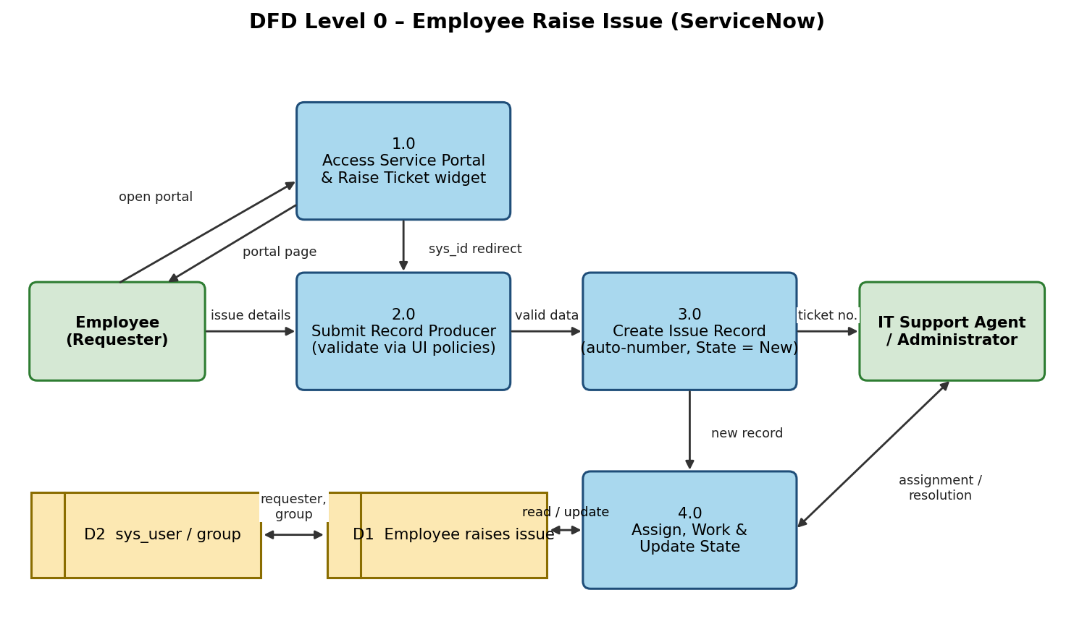

3.4 Technology Stack
The solution is built entirely on the ServiceNow platform:
S.No | Component | Description | Technology
1 | User Interface | Employee uses the Requesting portal (/employee_request) in a browser | HTML, CSS, Bootstrap and AngularJS (Service Portal), Employee Center Coral theme
2 | Application Logic | Left widget (services info) and right widget (Raise Ticket redirect); record producer, UI policies and dictionary dependency | Service Portal widgets, AngularJS client controller, Service Catalog, UI Policies
3 | Database | Custom table “Employee raises issue” | ServiceNow platform database
4 | File Storage | Portal logo and catalog item picture | ServiceNow attachment storage
5 | Infrastructure | Deployed on the ServiceNow cloud | ServiceNow Personal Developer Instance

4. PROJECT DESIGN

4.1 Problem Solution Fit
CUSTOMER SEGMENT  Employees who need to report IT or workplace issues; support agents who handle them. | CUSTOMER CONSTRAINTS  No simple standard form; users may not know where to report. | AVAILABLE SOLUTIONS  Email, chat or calling a colleague – untracked and unstructured.
JOBS-TO-BE-DONE  Report an issue quickly and know it is recorded. | PROBLEM ROOT CAUSE  Issues are raised informally with no template, numbering or validation. | BEHAVIOUR  Employees email and follow up manually.
TRIGGERS / EMOTIONS  Laptop, VPN, software or access problem. Before: frustrated. After: reassured. | YOUR SOLUTION  A Requesting portal with a guided record producer that creates a numbered record. | CHANNELS  Online: Service Portal in a web browser.

4.2 Proposed Solution
S.No. | Parameter | Description
1 | Problem Statement | Issues are raised informally, so data is incomplete and status is unclear.
2 | Idea / Solution description | A record producer and Service Portal widgets on a custom table so employees raise issues from one guided form.
3 | Novelty / Uniqueness | Dependent Category/Subcategory choices, UI-policy validation and a portal with a one-click Raise Ticket widget.
4 | Social Impact / Customer Satisfaction | Employees get a clear, quick way to report problems; support agents receive complete tickets.
5 | Business Model (Revenue Model) | Internal tool with no external revenue; value comes from saved time and better data.
6 | Scalability of the Solution | Built on a configurable table, so categories, fields and widgets can be added without redesign.

4.3 Solution Architecture
The architecture shows the user, the ServiceNow cloud (portal, widgets, record producer, platform logic and database) and how they connect.
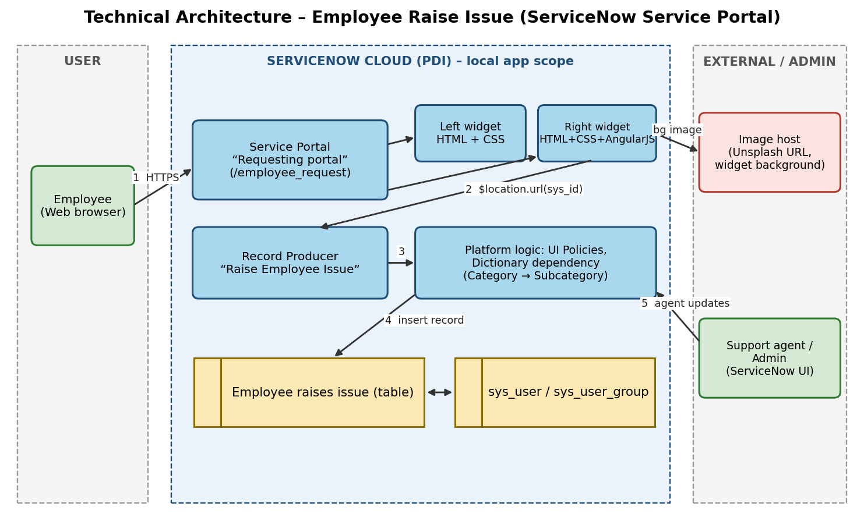

5. PROJECT PLANNING & SCHEDULING

5.1 Project Planning
The backlog has 12 user stories across 2 sprints, with story points on a Fibonacci scale (1, 2, 3, 5). Planned period: 28 September to 11 October 2026.
Sprint | Epic | US # | User Story | Pts | Priority
Sprint-1 | Build & Configure | USN-9 | Create the custom application, table, fields and auto-numbering. | 3 | High
Sprint-1 |  | USN-10 | Make the Number field read-only with a UI policy. | 1 | Medium
Sprint-1 | Raise Issue | USN-4 | Fill Requester, Category, Subcategory, State and Short description through the record producer and submit. | 5 | High
Sprint-1 |  | USN-5 | Show only the subcategories that match the chosen category. | 3 | Medium
Sprint-1 | Validation | USN-6 | Short description mandatory when State is New. | 2 | High
Sprint-2 | Build & Configure | USN-11 | Create the portal, page and widgets in a 6×6 container. | 5 | High
Sprint-2 | Access Portal | USN-1 | Open the Requesting portal and see the logo, banner and widgets. | 3 | High
Sprint-2 |  | USN-2 | Read the Commercial widget about the support services. | 2 | Low
Sprint-2 | Raise Issue | USN-3 | Click the Raise Ticket widget to open the Raise Employee Issue form. | 3 | High
Sprint-2 | Handle Issue | USN-7 | Support agent views new issue records. | 2 | High
Sprint-2 |  | USN-8 | Support agent updates State to In progress, Resolved or Closed. | 2 | Medium
Sprint-2 | Testing & Validation | USN-13 | Test the portal end to end (widgets, record producer, UI policies, dependency). | 3 | High
Sprint tracker:
Sprint | Total Points | Duration | Start Date | End Date (Planned) | Points Completed
Sprint-1 | 14 | 7 Days | 28 Sep 2026 | 04 Oct 2026
Sprint-2 | 20 | 7 Days | 05 Oct 2026 | 11 Oct 2026
Total story points = 14 + 20 = 34 across 2 sprints, giving a velocity of 17 story points per sprint (34 ÷ 2) and an average velocity of about 2.43 story points per day (17 ÷ 7).

6. FUNCTIONAL AND PERFORMANCE TESTING

6.1 Functional Testing
The planned test cases cover the portal, record producer, validation and dependency rules, and the support agent update. Full steps are in the User Acceptance Testing document.
Test ID | Scenario | Test Steps | Expected Result
TC-001 | Open the Requesting portal | 1. Open https://dev280178.service-now.com/employee_request  2. Scroll down the page | Portal loads with the logo, banner image and both widgets (left services widget, right Raise Ticket widget) side by side
TC-002 | Raise Ticket widget opens the form | 1. Click the Raise Ticket widget/link on the portal | Browser redirects to the Raise Employee Issue record producer
TC-003 | Submit an issue with valid inputs | 1. Open the record producer  2. Select Requester, Category, Subcategory, State  3. Enter Short description  4. Click Submit | Record is created in the Employee raises issue table with an auto-generated Number and the entered details saved
TC-004 | Requester reference field | 1. Click the Requester field in the record producer  2. Search for a user | Requester is picked from the sys_user table (not free text) and is saved on the record
TC-005 | Short description mandatory when State is New (negative) | 1. Open the form with State = New  2. Leave Short description blank  3. Click Submit | Short description shows as mandatory; submission is blocked and no record is created
TC-006 | Category → Subcategory dependency | 1. Select Category = Network, then Hardware, Software, Access  2. Check the Subcategory list each time | Network→VPN, Hardware→Laptop, Software→Server, Access→Forgot password; no unrelated options shown
TC-007 | Number field is read-only | 1. Open a record on the Employee raises issue form  2. Try to edit the Number field | Number cannot be edited; the value is auto-generated
TC-008 | Support agent updates State | 1. Log in as a support agent / admin  2. Open the submitted record  3. Change State to In progress, Resolved, then Closed | State change is saved and visible on the record
Status: UAT execution is pending. All 8 test cases are currently Not Tested and no defects are logged. Update this section with the pass/fail counts and any bug IDs after execution (see the UAT Report).

7. RESULTS

7.1 Output Screenshots
Insert screenshots here: (1) the Requesting portal with both widgets, (2) the Raise Employee Issue record producer, and (3) the created record in the Employee raises issue table.

8. ADVANTAGES & DISADVANTAGES

8.1 Advantages
- One guided form replaces unstructured email or chat.
- Every issue gets a unique auto-generated number.
- Category → Subcategory dependency and mandatory-field validation improve data quality.
- Built natively on the ServiceNow platform, with no new infrastructure.

8.2 Disadvantages / Limitations
- No email notification on state change yet.
- No automatic assignment or priority calculation; the support agent sets these.
- No employee-facing “My Issues” status widget yet.
- The developer instance may hibernate when inactive.

9. CONCLUSION
This project provides a structured way to raise workplace issues on the ServiceNow platform: a custom table, a record producer with validation and dependent choices, and a Requesting portal with two widgets. The build covers the core flow from the portal to a numbered record that a support agent can update. UAT is the remaining step before wider use.

10. FUTURE SCOPE
- Email notification to the employee on every state change.
- Automatic assignment to a support group and priority calculation.
- “My Issues” widget so employees can check status.
- Dashboards and reports for support teams.
- Extend the portal to more issue categories and departments.

11. APPENDIX
Source Code: Configured natively in the ServiceNow instance (custom application, table, record producer, UI policies and Service Portal widgets). Export as an Update Set if a portable copy is required.
Dataset Link: Not applicable – no external dataset is used.
GitHub & Project Demo Link: [add your GitHub link here] | Demo: https://dev280178.service-now.com/employee_request

